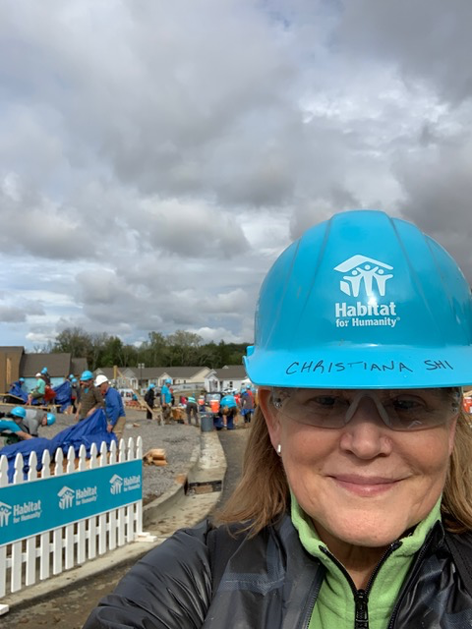

CREW member Christiana Smith Shi says “My passion is helping women and child thrive – and safe and secure housing is critical to that goal. Habitat gives me an effective way to work with others to reach a collective aspiration where everyone has a decent place to live.” As a member of the Habitat for Humanity International Board of Directors, Christiana has many opportunities to act on that passion, and her consultancy, Lovejoy Advisors allows her to work at the highest levels of corporate America, building on her career of leading and advising corporate teams at McKinsey and Nike. And why Women Build in Portland? “I love being empowered and empowering other women to create affordable housing in our community. And, I also appreciate learning home maintenance skills which I can take away and use on my own home!” Thank you, Christiana, for making Women Build stronger.

