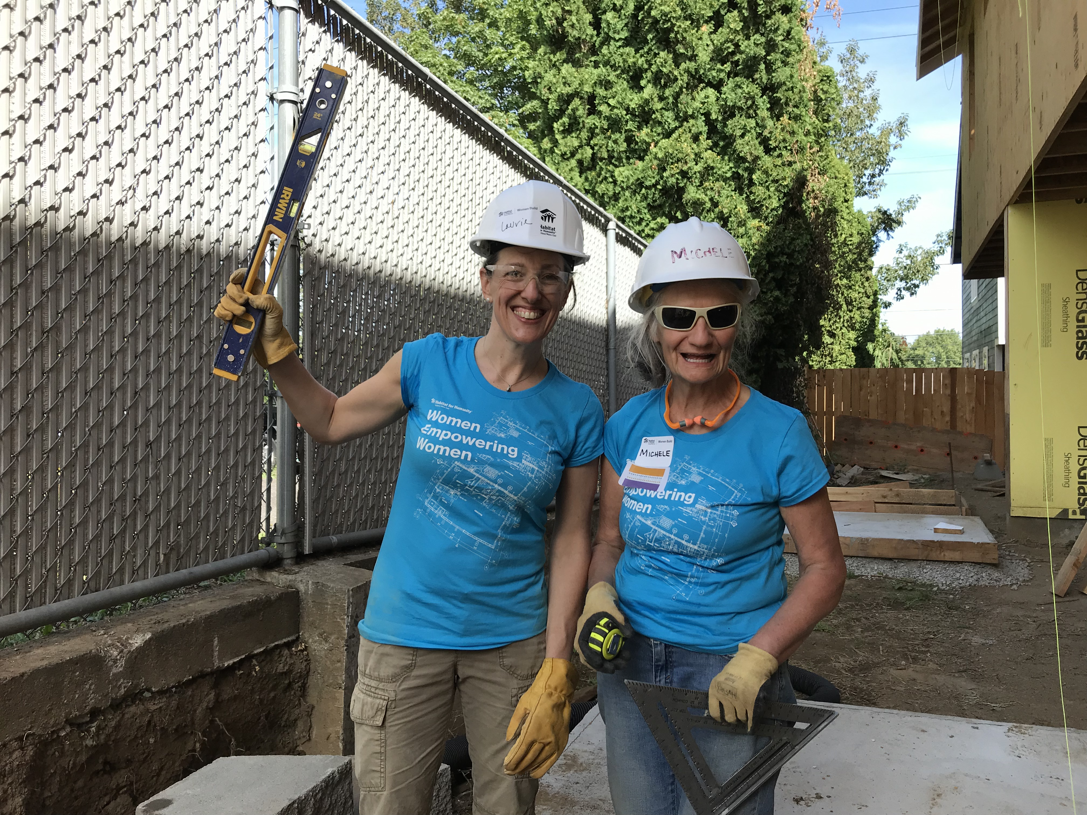

CREW member Laurie Thomas (here, on the left, level held aloft!) is a longtime leader in one of Portland’s iconic companies, Danner Boots. With Laurie’s help, Habitat proudly profiled women at work in an inspiring campaign to uplift women working in the trades. When asked, ‘why Habitat?’ Laurie’s shares an astute observation: “Safe, reliable housing is a fundamental right for all, and we owe it to ourselves and our community to do all we can to help people establish and maintain a stable home. With a place to live, families can focus on work, school and other connections that change lives for the long run.” And her commitment deepens as she recognizes how Women Build grows in relevance today: “Women-led households face some of the greatest challenges in our community.
Finding a safe, affordable community to raise children and build a future is such a challenge for so many. We must find opportunities to support our fellow mothers, sisters and daughters, helping to build a path towards independence and success.” Thank you, Laurie, for making Women Build stronger!

