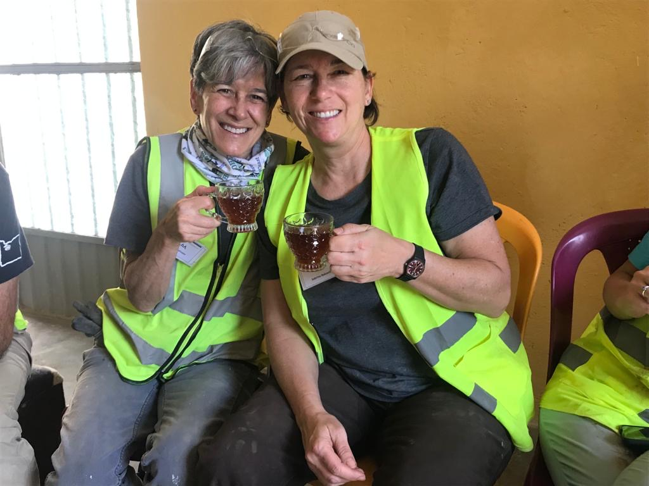

Leslie Johnson (pictured here on the left with her wife, Sabrina) has been one of Habitat’s most regular of our Regular volunteers. And Women Build CREW was made possible because of her early leadership and encouragement. After building and then selling her successful environmental engineering company, Montrose Environmental Group, Leslie put her energy into Habitat in Portland. Women Build has benefited ever since. “Women on the build sites have been underrepresented at Habitat, by no fault of the organization. It has been wonderful meeting empowered, educated, compassionate women, all wanting to help people, more specifically women, to be their best. The group is some of the most generous women I have ever met. Generous in their time, money, ideas and energy.” To Leslie, Habitat’s place in the world is vital. “Having a safe and stable place to live is paramount to so many of life’s successes; a good job, education, emotional and physical health, etc. Habitat’s model of building high quality homes for and with low-income families helps to fill this hole. Habitat also provides an amazing place for volunteers to assist with this dream. Habitat has taught me building skills, it has been a wonderful place to meet engaged people, it has made me want to educate myself on many social issues that affect so many people. Habitat builds communities in the neighborhoods we build and while we build them.” Thank you, Leslie, for helping Women Build stronger!

