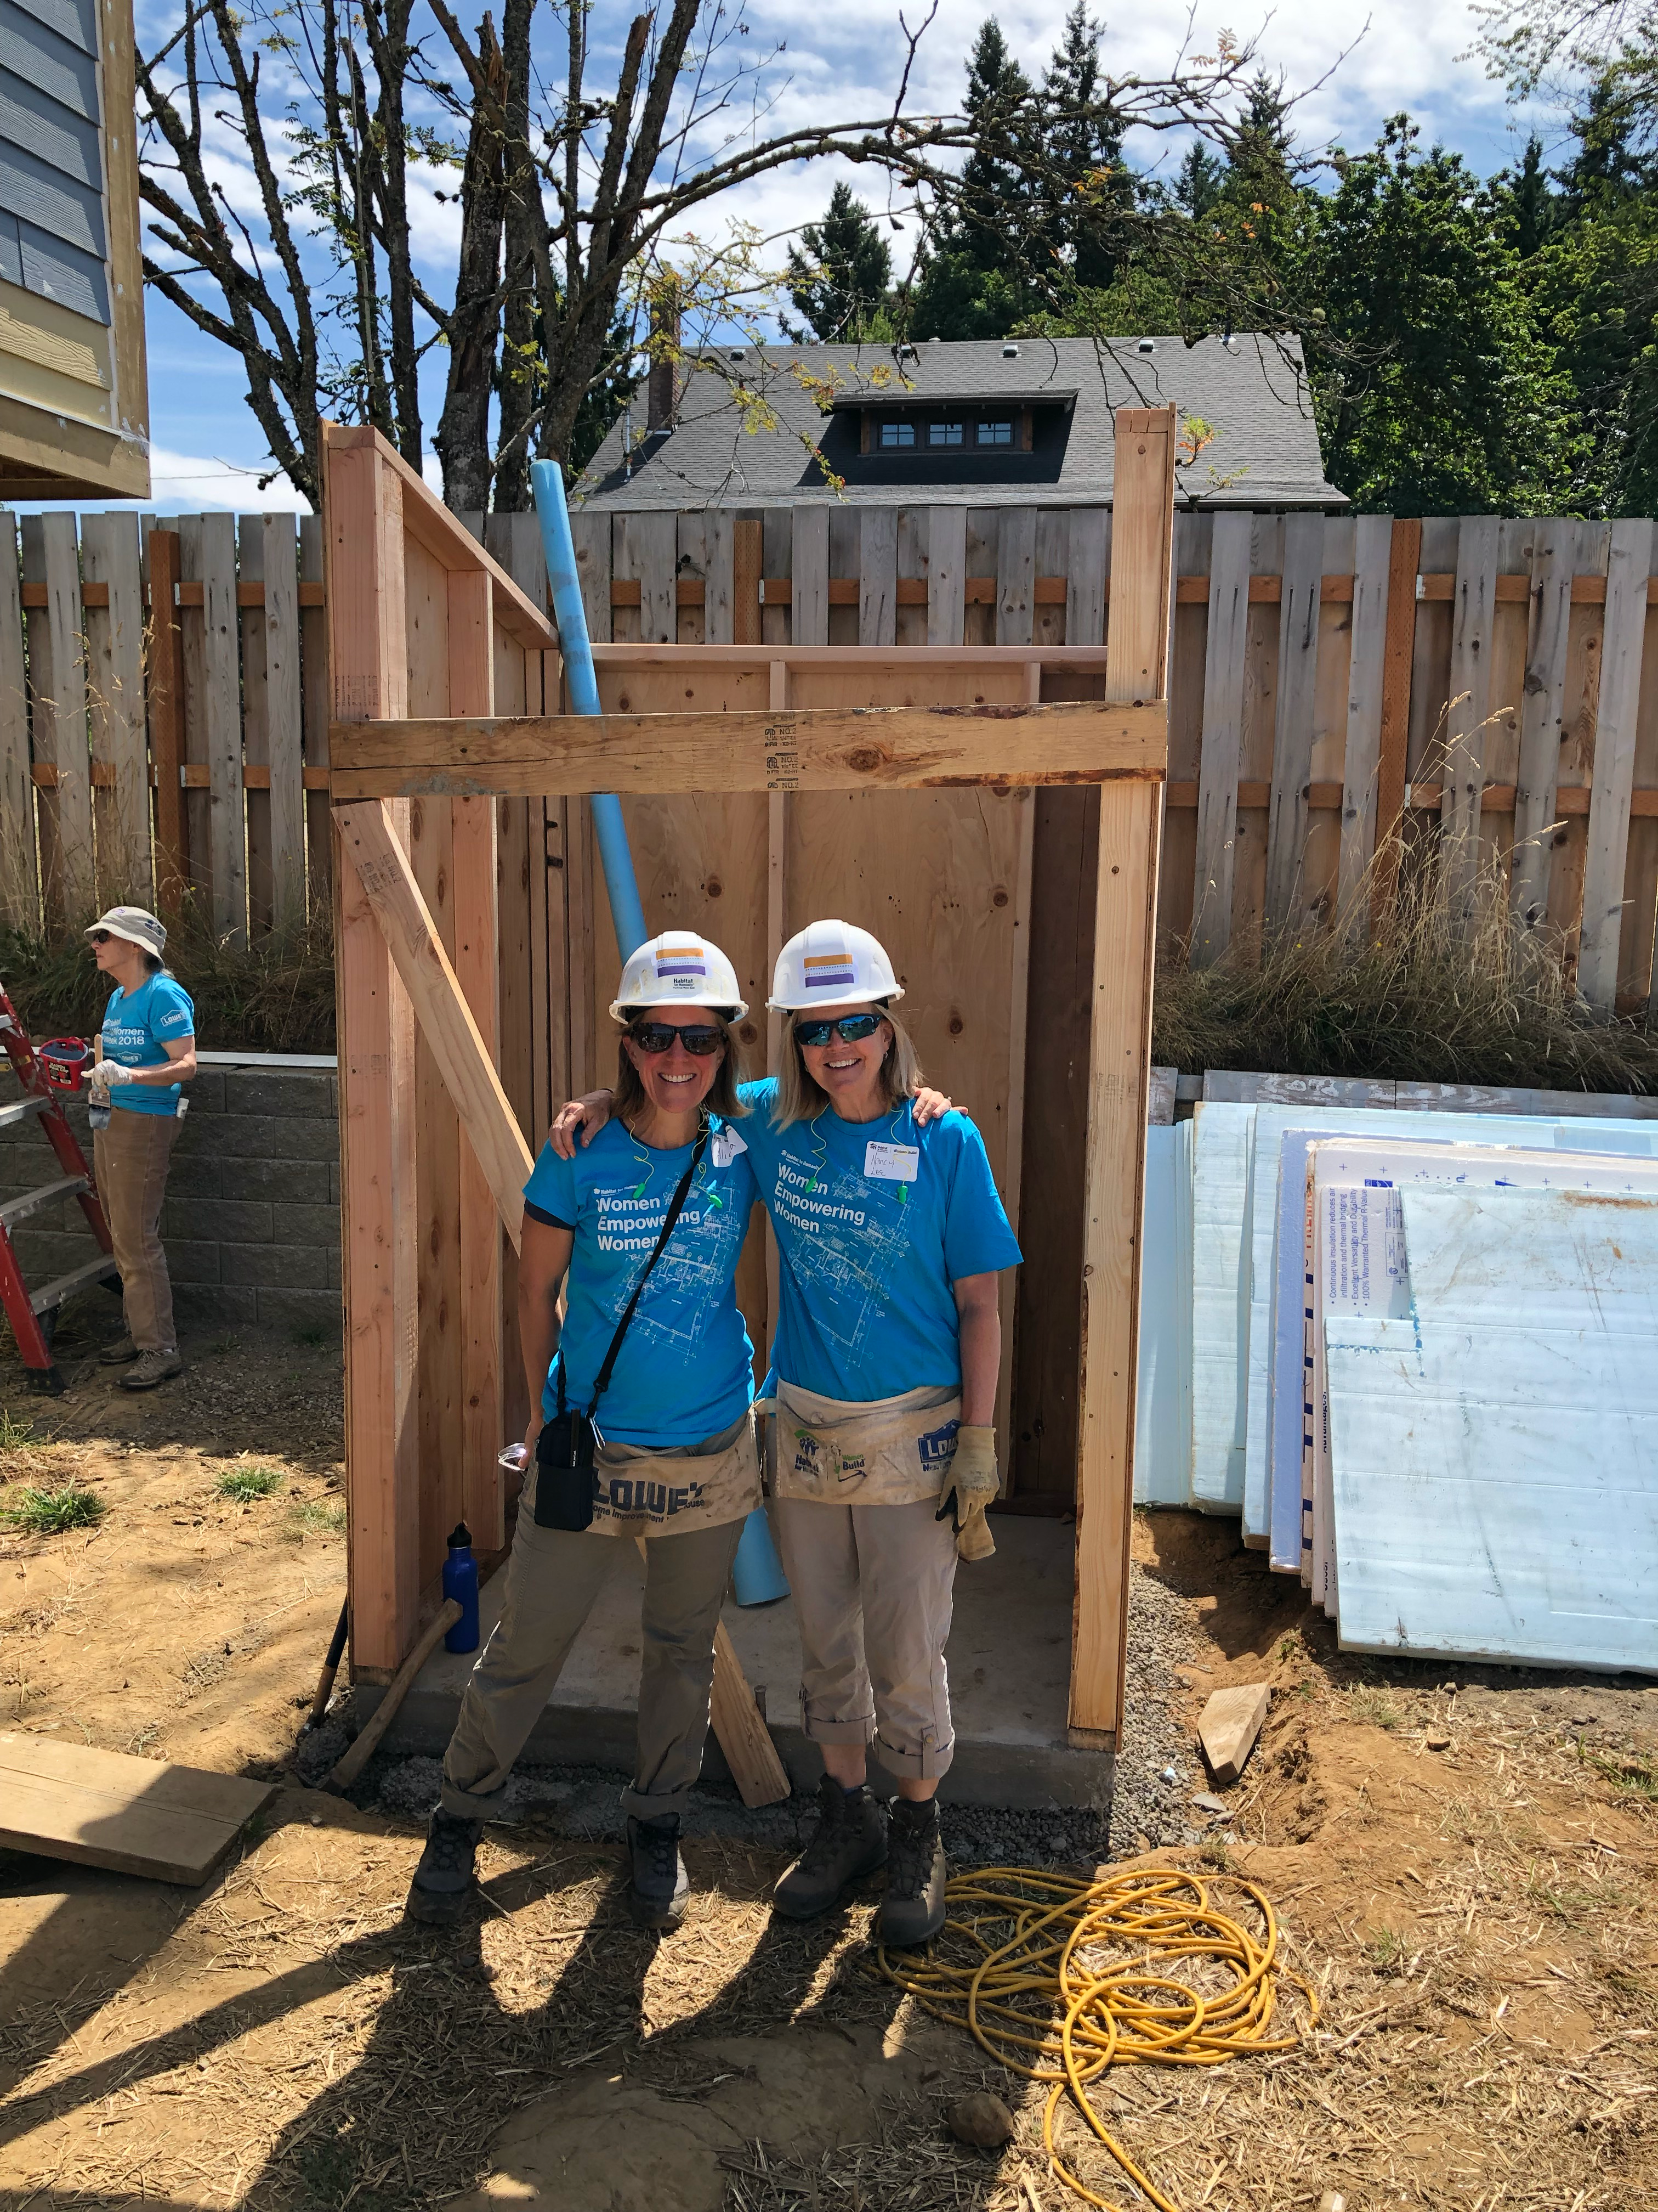

CREW member Nancy Lee (pictured here, on the right) is newly, and very happily retired from an accomplished career at major companies including Nike and Gap, Inc. “I love being involved in an organization that helps people in such a fundamentally important way. Habitat creates the opening for people, who otherwise could not afford it, purchase a home for themselves and their families. It is so gratifying to see the joy and greater sense of security this introduces into their lives.” Thanks to an invitation from a friend, she first joined a Portland Habitat Women Build day in 2019 - and got hooked on Habitat! She saw right away how “Women Build provides opportunities for women to get engaged in the important work that Habitat does. It has been a great way to meet other women looking to get engaged, to get my hands dirty learning some new building skills, and to contribute to helping women and their families become proud owners of a home of their own.” Thank you, Nancy, for making Women Build stronger!

